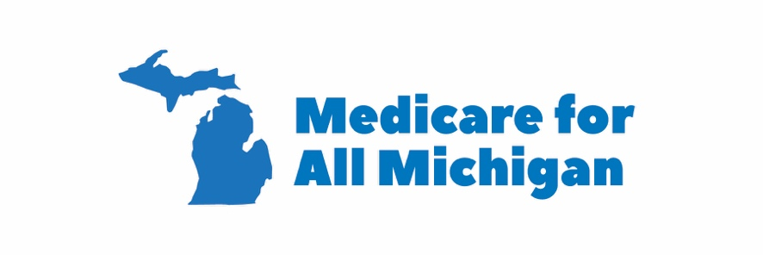

WHY MEDICARE FOR ALL?

- Healthcare is a Human Right, not a for-profit scheme

-Health is not a commodity to be profited from, like other commodities. How rich a person is should not determine whether they get to live or die when they’re sick. The Pope, the UN, and most religions and cultures also believe this. So too do 60% of Americans, 60% of independents, over 40% of Republicans, and 85% of Democrats.

- Eliminate cost-sharing

-Improved Medicare for All (“single payer”) would eliminate co-pays, deductibles, and premiums. These are main ways that insurance companies make money off of us, and are prohibitive for many Americans. Whatever people pay in higher taxes less than what they pay now out of pocket. Cost-sharing was an accident of history, based on a faulty assumption that people will “overuse” healthcare if it didn’t exist; all data (from other countries, from VA or Medicaid eg) shows this is untrue.

- Almost unlimited choice of provider

Currently, those who have insurance are limited to participating providers, and in rural areas this can mean prohibitive distances. Often, people find one part of their treatment is “out of network” and they get huge bills. 95% of providers accept Medicare; in Improved Medicare for All (Single Payer), this means that almost all providers will be “in-network.”

- Most efficient and least expensive model

It is well known that the US spends more than twice what other industrialized countries do per capita on healthcare, yet we have far worse outcomes than most. By eliminating administrative overhead, and the profit motive from insurers, having a huge pool that can spread risk and negotiate with big pharma and medical device manufacturers, we can save $500 billion nationally per year.

- Let providers focus on providing

The average doctor spends 40% of their time now on paperwork, much of it dealing with insurance companies; for hospitals it is the same, having to negotiate the price of every procedure, medicine, and device from every insurance company every year. In Improved Medicare for All, doctors and hospitals would be able to spend almost 100% of their time on treatment. Medicare for All will also dramatically reduce malpractice insurance as well.

- Good for entrepreneurship

There is an increasing phenomenon called “job lock” -- meaning that people stay in jobs they don’t want to because they cannot afford to start a new business or non-profit, or go back to school, etc. because they depend on the benefits of the company for which they work. Employer-based health benefits were, like cost-sharing, an accident of history based on a faulty assumption (that people would be more motivated to work if their lives depended on it; people generally work regardless of benefits).

- Good for employers

The average American family spends $8000 a year on premiums, but their employer spends on average $13,000 a year. About half the work of HR departments is devoted to dealing with health plan administration. Under Improved Medicare for All, all this expense and overhead would go away. So too would a large portion of Workers’ Comp expenses.

- Good for unions

One of the main points of contention in collective bargaining negotiations is health benefits. Under Improved Medicare for All, health benefits would no longer be a point of leverage that management would have over unions, allowing them to focus more on wages and pensions, etc.

- Good for the overall economy

A healthy population means a wealthy population. 2.5 billion hours are lost to the economy to illness, much of this chronic illness, much of which is due to untreated conditions. This lack of productivity is passed to us in the form of higher prices. 60% of bankruptcies are due to health bills (and likely many other credit care bankruptcies are due to health bills too). The cost of these bankruptcies are passed to us as higher finance charges. High medical costs are responsible for higher auto insurance and home insurance rates, and they are a major driver of other costs such as tuition, the costs of state and municipal government. All these costs would be lowered in a Medicare for All system.

- We’re the only ones who don’t have a some form of it

Every modern country, and even some developing countries, have a form of universal health care except us. Why? If the answer is that the power of the insurance lobbies and big pharma are preventing it, then that is unacceptable for this country.
CONTACT
www.medicareforallmichigan.org
Facebook: www.facebook.com/Medicare4AllMI
Twitter: @Medicare4AllMI
Email: Medicare4AllMichigan@gmail.com

